# SOLUTION ARCHITECTURE

**Design:**

* Garbage level detection in bins.
* Getting the weight of the garbage in the bin.
* Alerts the authorized person to empty the bin whenever the bins are full.
* Garbage level of the bins can be monitored through a web App.
* We can view the location of every bin in the web application by sending GPS location from the device.

# Software and system required:

* + Arduino IDE
  + Embedded C
  + 4GB processor and OS-Windows/Linux/MAC

# Block diagram:



User

Cloud Service

IOT DEVICE

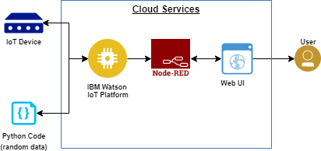

**IOT Device**

GPS/GSM

ARDUINO***/***

NODEMCU ESP8266

IR/ULTRASONIC SENSORS/LOAD CELL

**Cloud Service**



Cloud DB

Geofence

Web UI

IBM Watson

Node red